Poultry Monitoring and Simulation System
Project Documentation

Introduction
The Poultry Monitoring and Simulation System is a web-based application developed to address common challenges faced in poultry farm management. Poultry farming requires constant attention to environmental and operational conditions such as temperature, humidity, air quality, feeding levels, water availability, and bird activity. Any imbalance in these conditions can negatively affect bird health, growth rate, egg production, and overall farm profitability.
In many traditional poultry farms, monitoring is performed manually or through occasional inspections. This approach is often inefficient, inconsistent, and incapable of providing early warnings when conditions become unfavorable. As farms grow in size or are divided into multiple sections, it becomes increasingly difficult to maintain close supervision across all units.
This system introduces a digital solution that simulates a smart poultry monitoring environment. It allows users to create and manage poultry blocks, observe real-time simulated environmental data, receive alerts when conditions exceed safe limits, and review historical records to identify trends. Although the system uses simulated data rather than physical sensors, it closely mirrors how a real-world smart poultry monitoring system would function.
The Poultry Monitoring and Simulation System is designed not only as a management aid but also as an educational and demonstration tool. It helps users understand how environmental factors affect poultry welfare and how technology can be applied to improve decision-making in modern agricultural practices.

System Analysis
The development of this system was driven by several real-world problems commonly encountered in poultry farming. One major issue is the lack of continuous monitoring. Environmental conditions within poultry houses can change rapidly due to weather, overcrowding, poor ventilation, or equipment failure. Without real-time monitoring, farmers may not notice these changes until birds begin to show signs of stress or illness.
Another challenge is managing multiple poultry units simultaneously. Large farms often divide birds into separate blocks based on age, breed, or purpose. Monitoring each block individually using manual methods is inefficient and prone to errors. There is also the problem of insufficient record keeping. Many farmers do not maintain detailed historical records of environmental conditions, making it difficult to analyze past performance or identify recurring problems.
These challenges informed the core objectives of the Poultry Monitoring and Simulation System. The system needed to support multiple users securely, allow each user to manage multiple poultry blocks independently, and provide a structured way to monitor and record environmental data. It also needed to include an alert mechanism to notify users of abnormal conditions and a historical data feature to support long-term analysis.
The system was analyzed from both a functional and non-functional perspective. Functionally, it needed to be easy to use, reliable, and capable of handling multiple simulations concurrently. Non-functionally, it needed to be secure, scalable, and maintainable. These considerations guided the overall design and implementation approach.

System Design
The Poultry Monitoring and Simulation System follows a structured and modular design that separates responsibilities across different components. At the user level, individuals interact with the system through a web interface where they can log in, manage poultry blocks, and view monitoring data. The interface is designed to be intuitive, ensuring that users with little technical knowledge can navigate the system easily.
Behind the interface is the application logic layer, which handles user authentication, block management, simulation control, alert generation, and data processing. This layer ensures that user actions are validated and processed correctly before interacting with the database or simulation engine.
A key component of the system design is the simulation engine. This engine generates realistic environmental data for each poultry block at regular intervals. The simulation is block-specific, meaning that each block operates independently. This design choice reflects real-world poultry farms, where conditions can vary between different houses or sections.
The database layer stores all persistent information, including user details, block configurations, sensor readings, and alerts. Data is organized in a relational structure to ensure consistency and efficient retrieval. The architectural diagram attached in this section illustrates how these components interact, showing the flow of requests from users to the system and the flow of data between the simulation engine and the database.
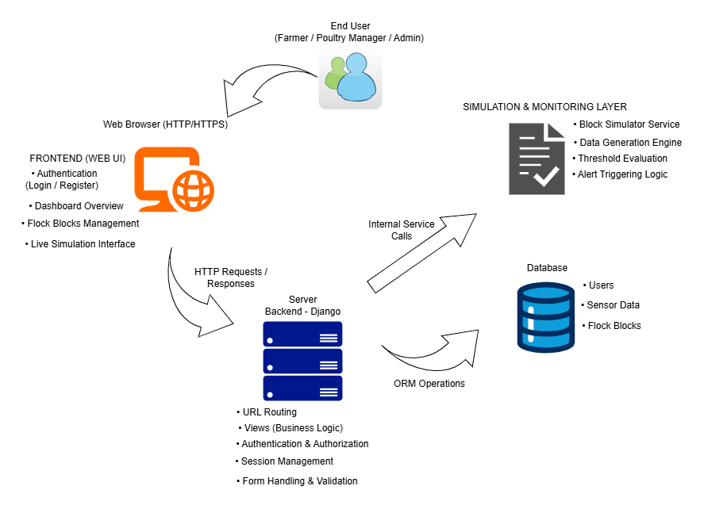

Figure 1: System Architectural Diagram

Features of the System
The Poultry Monitoring and Simulation System provides a range of features designed to improve poultry management efficiency and awareness.
- User authentication and account management ensure that each user has a secure and private workspace. Users must register and log in before accessing system features, protecting sensitive farm data from unauthorized access.
- Flock block management allows users to divide their poultry into logical units called blocks. Each block represents a group of birds with shared characteristics such as breed, age group, and housing conditions. This structure simplifies monitoring and reflects real-world farm organization.
- Live simulation monitoring is a core feature of the system. Once a block is created, users can start a simulation that generates real-time environmental data. Parameters such as temperature, humidity, ammonia levels, feed availability, water levels, and activity levels are continuously updated to reflect realistic fluctuations.
- The alert system automatically monitors simulated data and generates notifications when values exceed predefined thresholds. This feature helps users identify potential risks early and encourages proactive management.
- Historical data visualization allows users to review past sensor readings over different time ranges. By analyzing trends, users can better understand how conditions evolve over time and assess the effectiveness of management decisions.

Database Design
The database design is central to the reliability and effectiveness of the Poultry Monitoring and Simulation System. The system manages several interconnected data entities, each serving a specific purpose.
- User data stores authentication and identification information for each registered user. Poultry block data stores details about each block, including its name, bird count, breed, age group, and descriptive information.
- Sensor data records store time-stamped environmental readings generated by the simulation engine. These records form the basis for both real-time monitoring and historical analysis. Alert data stores information about abnormal conditions, including alert type, message, timestamp, and resolution status.

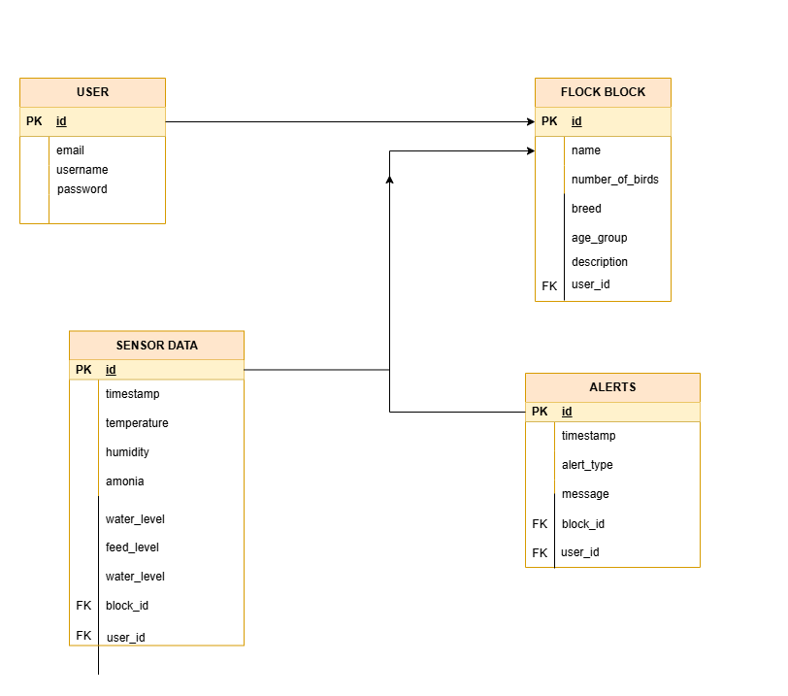

Figure 2: Entity Relationship Diagram (ERD)
The relationships between these entities ensure that each user can only access their own blocks and related data. The Entity Relationship Diagram attached in this section visually represents these relationships, helping readers understand how data is structured and connected within the system.

Technology Stack Used
The Poultry Monitoring and Simulation System was developed using a carefully selected set of technologies that ensure reliability, ease of development, and scalability. These technologies work together to support user interaction, data processing, simulation logic, and secure data storage.
The backend of the system is built using Python and the Django web framework. Django was chosen because it provides a strong structure for building secure and scalable web applications. It handles core application logic such as user authentication, access control, flock block management, simulation control, and alert generation. Django also simplifies database interactions and ensures data integrity through its built-in object–relational mapping system.
For data storage, the system uses a relational database approach. During development and testing, SQLite was used as the database because it is lightweight, easy to configure, and well-suited for rapid development. For deployment on PythonAnywhere, the system was configured to use MySQL, which offers better performance, scalability, and reliability for production environments. This separation between development and production databases ensures smooth testing while maintaining robustness in live deployment.
The frontend of the system is built using HTML5, CSS3, and JavaScript. These technologies are responsible for structuring content, styling the user interface, and enabling interactive elements. Bootstrap 5 is used to enhance the visual layout and responsiveness of the application, ensuring that pages are well-organized and accessible across different screen sizes.
Django’s server-rendered templates are used to dynamically generate pages based on user data and system state. This approach allows the application to deliver fast load times and consistent user experience without relying heavily on client-side frameworks.
Additional supporting tools and libraries are used to manage background simulation processes, serialize monitoring data for APIs, and handle alerts efficiently. Together, these technologies provide a stable and flexible foundation for the Poultry Monitoring and Simulation System, while also allowing room for future enhancements such as real sensor integration and advanced analytics.

Key Pages of the System
The system includes several key pages, each designed to support a specific user task.

- The Home Page introduces the system and guides users toward registration or login. It serves as the public-facing entry point of the application.
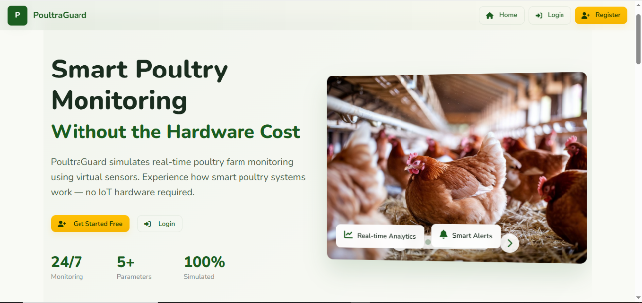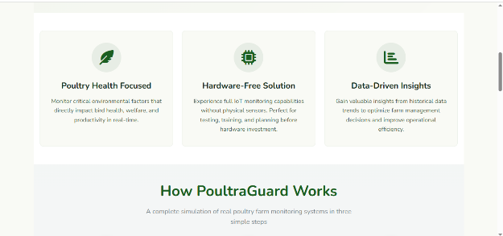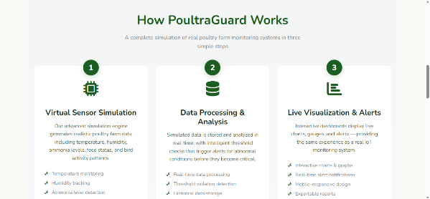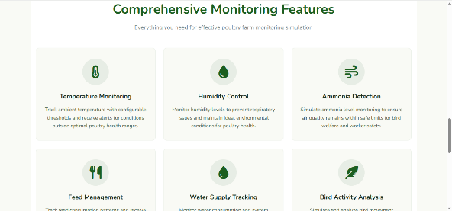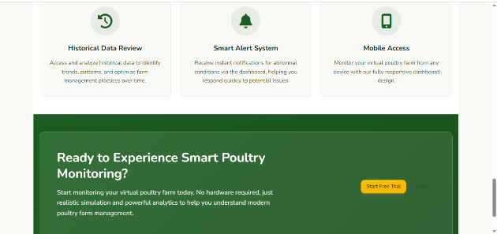

- The Dashboard provides a high-level overview of all poultry blocks owned by the user. It displays key performance indicators and summary information, allowing users to quickly assess farm conditions.

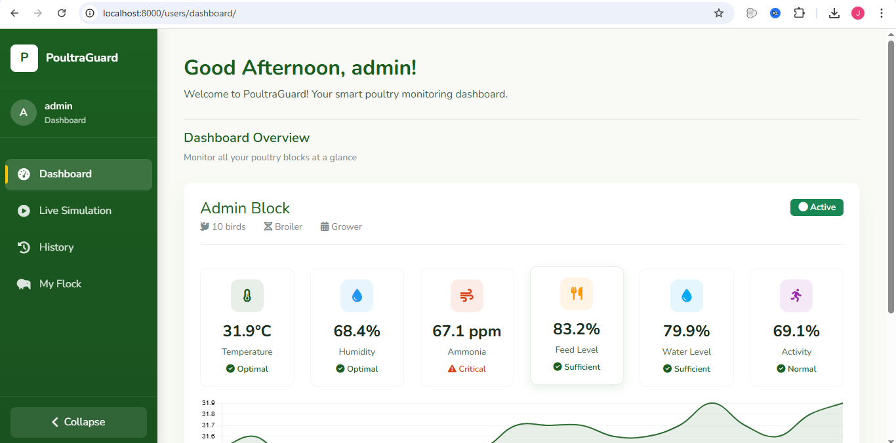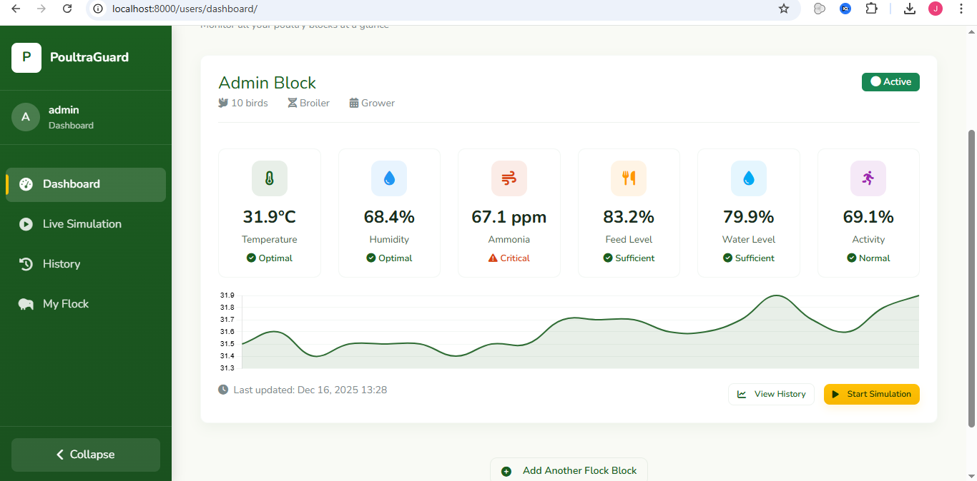

- The Blocks List Page shows all blocks created by the user in an organized format. From this page, users can view details, start simulations, or navigate to live monitoring.
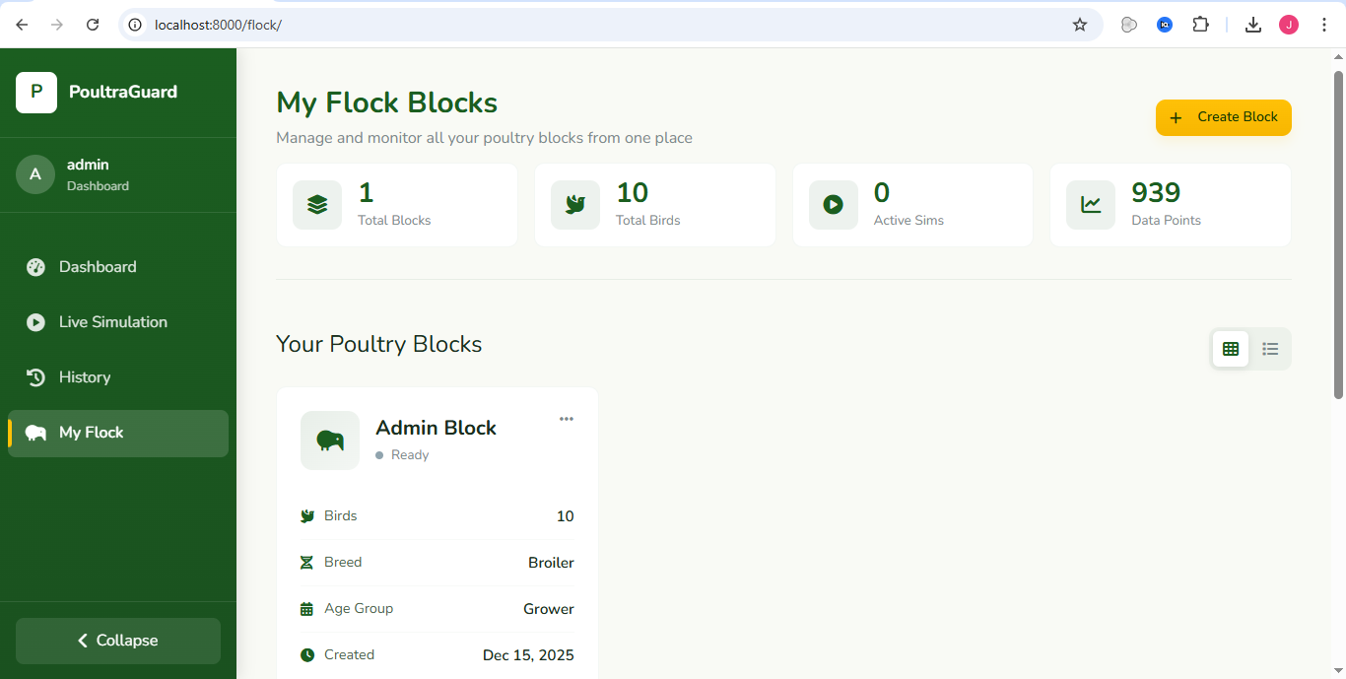

- The Live Simulation Page displays real-time monitoring data for a selected block. Users can observe changes as they occur and respond to alerts promptly.
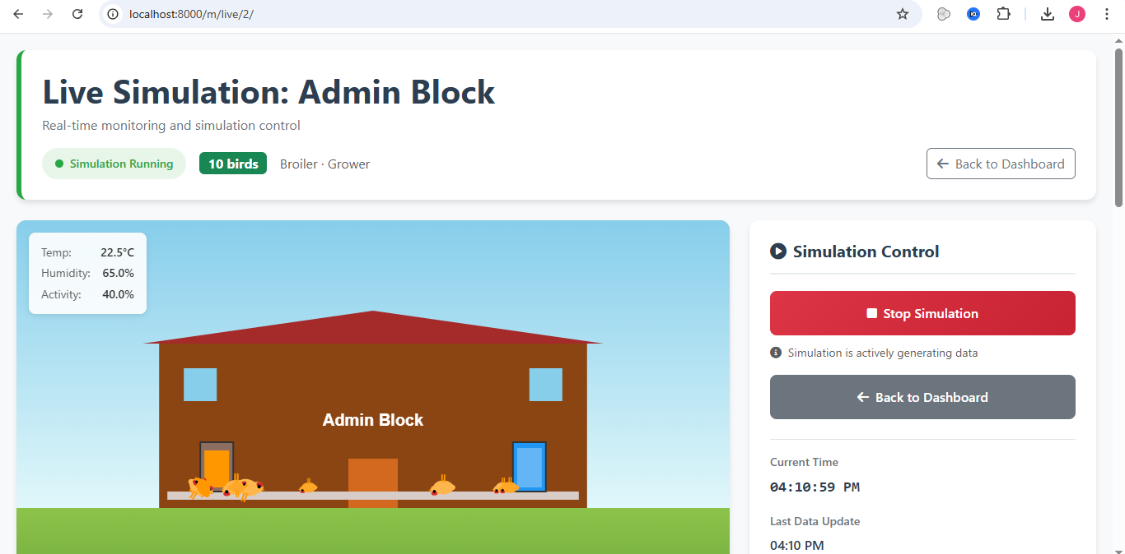

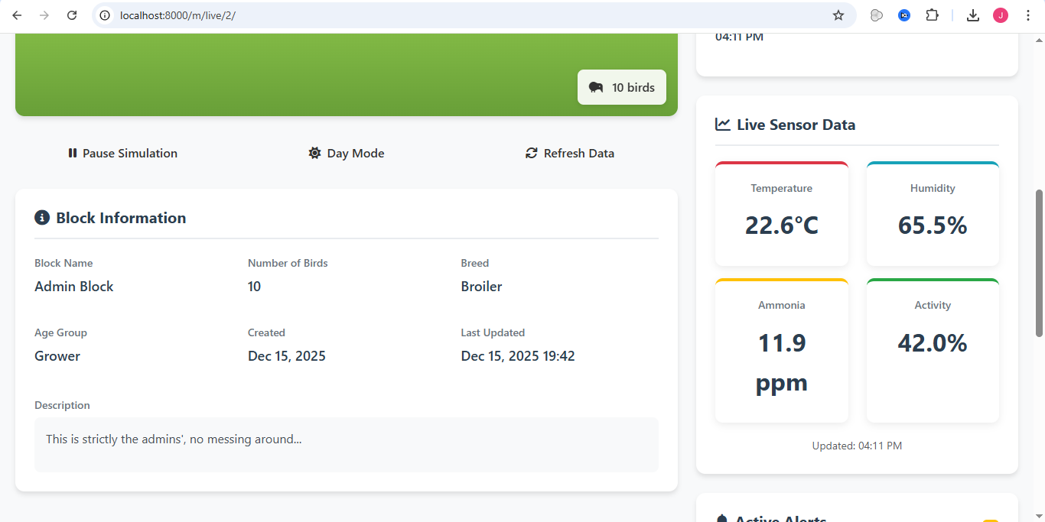

- The History and Records Pages provide access to past monitoring data. These pages support informed decision-making by allowing users to review trends and patterns over time.
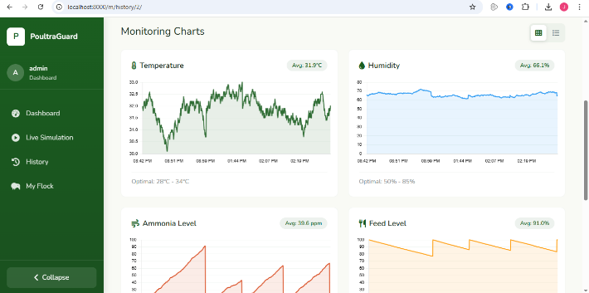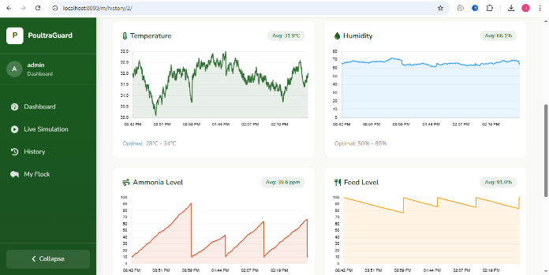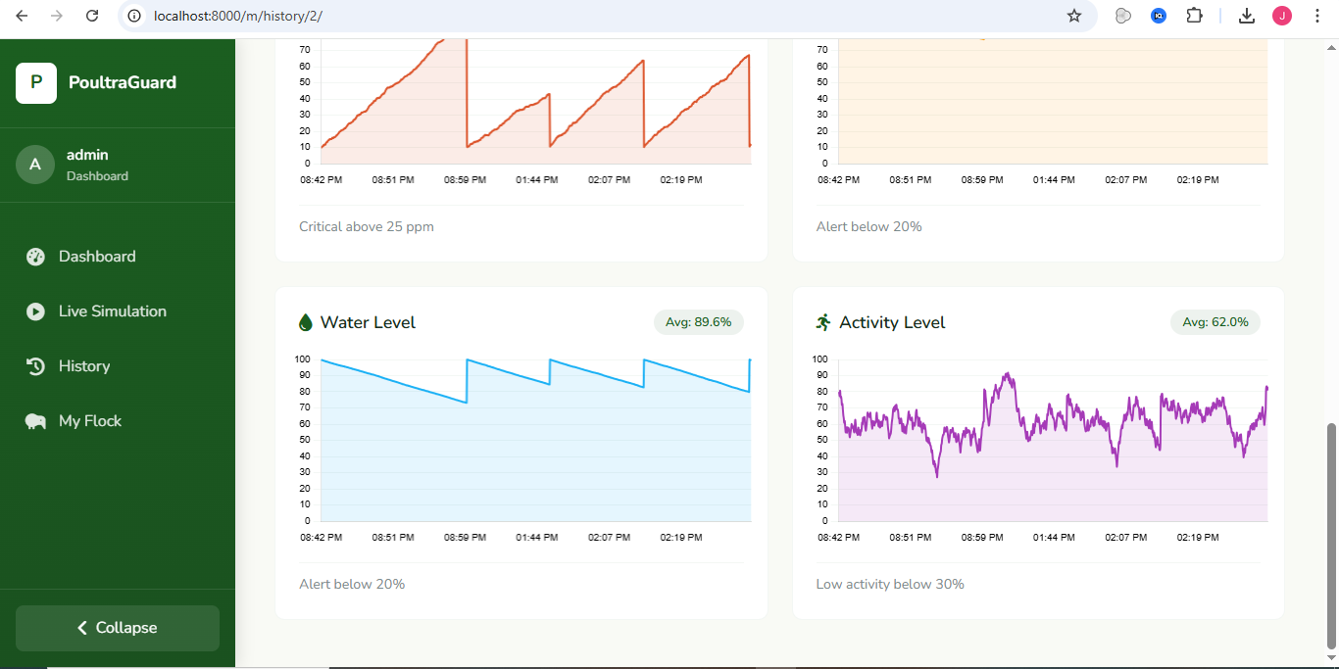

User Interaction and Workflow
The typical user workflow begins with account registration and login. After authentication, the user creates one or more poultry blocks based on their farm structure. Once a block is set up, the user can start the live simulation.
As the simulation runs, environmental data is generated and stored automatically. The user can view this data in real time on the live simulation page or later on the history pages. Alerts notify the user of any abnormal conditions, prompting timely intervention.
This workflow supports daily monitoring tasks while encouraging data-driven management practices. The Data Flow Diagram attached in this section illustrates how user actions trigger simulation processes and how data moves through the system.
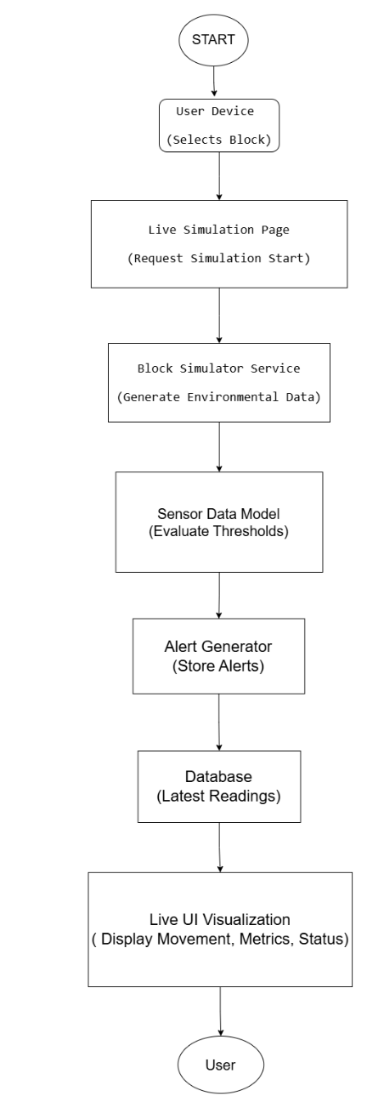
Figure 3: Data Flow Diagram (DFD)
Security and Access Control
Security is a fundamental aspect of the system design. Authentication mechanisms ensure that only registered users can access system features. Authorization controls restrict access to data, ensuring that users can only view and manage their own poultry blocks and monitoring records.
These measures protect user privacy and maintain data integrity in a multi-user environment.

Limitations of the System
While the system provides valuable insights, it has certain limitations. The monitoring data is simulated and does not reflect actual sensor measurements. As a result, the system cannot replace real-world monitoring equipment.
The system is currently optimized for small to medium-scale use and may require enhancements to support very large farms or enterprise-level deployment. Mobile optimization and offline support are also limited at this stage.

Future Enhancements
Future improvements could include integration with physical IoT sensors for real-time data collection, advanced analytics and predictive modeling, and automated recommendations based on observed conditions.
Other potential enhancements include mobile applications, expanded reporting tools, and integration with broader farm management systems.

Conclusion
The Poultry Monitoring and Simulation System demonstrates the practical application of technology in modern poultry management. By combining simulation, structured data management, and user-friendly interfaces, the system provides a comprehensive platform for monitoring poultry environments.
Although currently based on simulated data, the system establishes a strong foundation for future real-world integration. It highlights the importance of data-driven decision-making and showcases how digital tools can improve efficiency, awareness, and sustainability in poultry farming.

